Make Your Way to HKBU from the Hong Kong International Airport

By Bus: You may take Citybus No. E22 (time 0530-2400 hours) at the Airport Ground Transportation Center. Get off at “Kam Shing Road, Junction Road” bus stop (HK$18). The whole journey will take about 1 hour and 30 minutes. The bus stop is at the intersection of Junction Road and Renfrew Road. Walk across the street from the bus stop at the traffic light and along Renfrew Road. NTT International House will be on your left after a 5-minute walk.
By Taxi: You may take an urban taxi (red) at the Airport Terminus to HKBU which takes about 45 minutes and it costs about HK$300 (inclusive of bridge and tunnel fees). In addition, HK$6 (red taxi) will be charged per piece of baggage. Show the taxi driver the address label below. You can use this address when you need a taxi to get to HKBU during your stay in Hong Kong (some taxi drivers do not speak and/or understand English).

By Airport Express Train: You may take the Airport Express Train to the Kowloon Station (HK$105). From the Kowloon Station, then take a taxi to HKBU. The ride takes about 20 minutes and it costs about HK$75 (inclusive of baggage).

Address Labels in Chinese and English

NTT International House

NTT International House
Hong Kong Baptist University, 32 Renfrew Road, Kowloon Tong, Kowloon, Hong Kong
Phone: 2301-2301

香港九龍塘聯福道32號
香港浸會大學吳多泰博士國際中心
電話：2301-2301

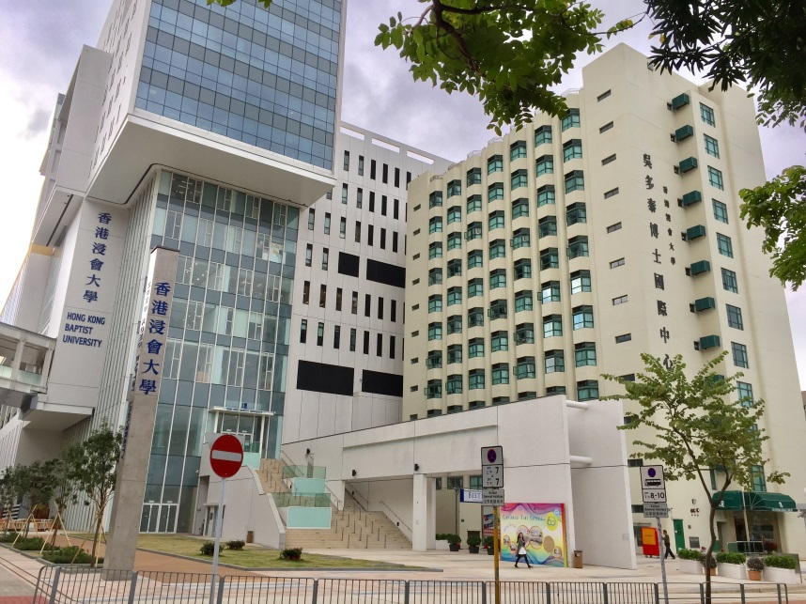
Building on the right: NTT International House

